From: https://www.strategic-culture.org/news/2020/11/17/lord-malloch-brown-revealed-the-british-hand-behind-coup-shows-its-scales-again/
Also found at: https://canadianpatriot.org/2020/11/17/malloch-brown/
Keywords: trifold deep state,

Lord Malloch Brown Revealed: The British Hand Behind the Coup Shows Its Scales Again
By: Matthew Ehret
Date: November 17, 2020
Throughout the four-year drama of Russiagate, the hand of British intelligence has revealed itself continuously.
From the obvious role of Sir Richard Dearlove and his former MI6 underlying Christopher Steele who together played a driving role in shaping the dodgy dossier, to their involvement with Oxford Rhodes Scholar Strobe Talbott in composing, promoting and marketing the fraudulent dossier to targeted members of Congress and media, to British Ambassador Sir Darroch caught “flooding the zone” with British intelligence assets to shape Trump’s perception of the world, to the array of British entrapment operations that targeted Michael Flynn as early as 2014 in London… wherever one looks, the hand of British intelligence seems to be everywhere.
While vast effort is made to downplay the British roots of the deep state by the media which tends to portray this problem from a partisan narrative of “democratic party corruption”, this sleight of hand misses the causal nexus and demands we believe that the tail truly wags the dog.
The uncomfortable truth which many are either too afraid, lazy or corrupt to admit is that since the moment John F Kennedy died on November 22, 1963, both the Democratic and Republican Parties have undergone an slow take-over by this foreign parasite. The thing that has come to be known as the “deep state”
- was never based on one party or another, and
- never emanated from anything native to the Constitutional traditions of the US government itself
as I outlined in my previous article “Understanding the Trifold Nature of the Deep State”.
While the Republican party of George Bush was in power, this deep state had used its controls of computerized vote counting to rig elections in 2000 and 2004 in its favor as showcased brilliantly in the 2006 documentary Hacking Democracy. Later, when it was time for a controlled opposition to take power in 2008, it did the same thing under a different cast of characters.
While one side of the unipolar world government agenda was
- driven by a view that the USA should forever be the primary global police force governing a zero sum system of perpetual war, with an unelected elite managing the system from above, the other side
- believed that the USA should surrender its claims to sovereignty to an international global body with unelected technocrats and financiers at the top managing the zero sum system of perpetual war from above.
Notice the common denominator?
Election Theft as Russiagate 5.0
Now that it has become increasingly clear that mass election fraud has swept across the USA in an effort to accomplish what four years of Russiagate failed to achieve, yet another light has fallen upon the British hand behind Biden which aims to dissolve any nationalist spirit remaining in the embattled republic.
As I outlined in my last report, the largest private computer voting system in the USA which services 30 states and 70 million voters was shown to be at the heart of the current election theft. In that article, it was made clear that Dominion Voting Systems is a Canadian company which dominates the USA’s private computerized voting systems and is closely tied to another larger company called Smartmatic.
For those still out of the loop, Smartmatic furnishes voting machines and its software (backdoor codes and all) to governments all around the world and is highly enmeshed with
- the Clinton Foundation,
- Soros’ Open Society and
- Nancy Pelosi’s very own Chief of Staff.
Not only that, but the key figure controlling Smartmatic is none other than Lord Mark Malloch Brown,
- a former vice chairman of George Soros’ Investment Funds (2007), as well as Soros’ Open Society Institute and World Economic Forum,
- former Vice President at the World Bank (1995-1999),
- UN Administrator for Development (1999-2005),
- UN Deputy Secretary General and UK Minister of State for Africa, Asia and the UN (2007-2009).
These are just a few hats he has worn in recent years which we will explore in greater detail.
Lord Malloch Brown: Not Your Typical British Agent
Through his lifelong affiliation with Soros, Lord Malloch Brown (Knight of the Order of St George and St Michael) played the role of color revolutionary godfather and key controller of such “technocrat friendly puppet leaders” as
- Corazon Aquino as well as her son Benigno Aquino III of the Philippines,
- [The nation of] Georgia’s George Saakashvili and even
- the hapless talking ego Barack Obama.
After working through an extended “apprenticeship” under the cover of UN aid worker, and marauding journalist for the London Economist, Malloch Brown found himself working for a Washington consulting firm named Sawyer Miller in 1985. It was at this time Malloch Brown was deployed to become the advisor and speech writer to Philippine opposition leader Corazon (Cory) Aquino under the supervision of then Secretary of State George Shultz. Corazon was a darling of the western establishment but had the nearly impossible task of challenging the popular nationalist President Ferdinand Marcos who had steered his country into economic sovereignty in opposition to international financiers for since his inauguration in 1965.
Applying all of the arts of perception management and marketing, Malloch Brown took control of Aquino’s campaign transforming it into the “People Power Revolution” that was in many ways the first successful color revolution of our modern times. Knowing that votes would likely favor the incumbent Markos, Malloch Brown wrote that he drafted Aquino’s victory speech before the elections and had her deliver it before votes were even finalized- and which accomplices in the media were all too happy to project publicly fueling the mythology that Corazon had won.
Describing these events years later, Malloch Brown said: “An outstanding accomplishment during the Cory campaign was to produce an exit poll that indicated that she had won. It landed on the front page of the Inquirer and had a profound impact as it planted the idea that Aquino had won over Marcos… Marcos did not really recover after that. It was a very exciting experience to watch.”
Malloch Brown failed to mention that the “polling station results” which produced the false perception that Corazon had won were manipulated by George Shultz’s local agents survey firms Social Weather Station, and Pulse Asia which have never been held accountable for their role in the anti-Marcos coup.
Shock Therapy
Soon after this “accomplishment”, Malloch Brown began working closely with George Soros on a number of projects that radically altered the world during the intense period of transition from a bi-polar to unipolar age.
In 1993, Soros had only recently carried out a speculative attack on the British pound sterling which resulted in $1 billion profit to the Hungarian speculator while providing the UK with a convenient excuse to avoid walking into the Euro trap which it had set for other European targets entering into the “post-nation state epoch”. In 1994, Soros announced a $50 million grant for “democracy building” operations in Macedonia and Bosnia which Malloch Brown was hired to administer as part of the Shatalin Shock therapy agenda.
From 1993-1994, Malloch Brown was part of the Soros Advisory Committee on Bosnia where advanced the Balkanization projects of the 1990s. In 1998, Malloch Brown also co-founded Soros’s International Criminal Court (ICC) after the duo had created the International Crisis Group (ICG) in 1994. These institutions served to 1) shape “international perception” of the causes and solutions to “crises”, real or fabricated and 2) advocate solutions that removed sovereignty in military and judicial affairs from sovereign nation states where they had been enshrined in the UN Charter, Nuremburg laws and UN Declaration of Human Rights, to supranational unelected organizations under the control of “experts”.
As Vice President of the World Bank from 1995-1999 he took credit for transforming its image to a more democratic organization, and from 1999-2005 led in the creation of the Millennium Development Goals which increasingly tied UN funding to George Soros’ Open Society operations internationally (during his time in New York, Malloch Brown lived on an estate owned by Soros).
R2P and More Color Revolution
During this period, Malloch Brown was among the earliest advocates of Responsibility to Protect (R2P) and did more than anyone else to incorporate the doctrine into United Nations “post-Westphalian” governance outlook in 2005 as UN Deputy Secretary General (2005-2006).
Demonstrating his imperial outlook on March 2011, the self-proclaimed “pacifist” grew impatient of nations who were reticent to blow up Libya and wrote in the Financial Times: “declare victory and get on with ousting Gadhafi”.
As co-chair of the International Crisis Group (which was born of seed money from Soros and on whose board of trustees sit Larry Summers, Joe Biden’s advisor Jake Sullivan and both George and Alexander Soros) Malloch Brown supported the narco-terrorist linked Kosovo Liberation Army which was also propped up by both the CIA and NATO during the Bosnia crisis coordinating closely with his Rhodes Scholar colleague Strobe Talbott who referred to Soros in 1995 as “a national resource—indeed, a national treasure.”
Describing Talbott, Malloch Brown recently wrote: “Strobe Talbott, is a very old friend of mine and in some ways a similar sort of practitioner and theoretician of globalisation… As such he really understood the hidden back-story of modern politics, which always gets shoved out of view by the more familiar story of nation-states.”
After bankrolling Georgia’s Rose Revolution in 2003 that put Soros’ Saakashvili in power, the Georgian state was rendered ungovernable due to a mix of vast incompetence and corruption. Here, Soros and Malloch Brown again came to the rescue by organizing a January 2004 event in New York that garnered $1.5 million for Georgian government reform programs (75% from Soros’ Open Society and 25% from the UN Development Program headed by Brown). The UNDP report justified the expense that was to pay Saakashvili’s salary as well as top government officials, and security forces when it said: “Georgia lacked the skilled professionals needed to design and execute sweeping reforms”.
The fact that these actions led to the murder of 1,600 in South Ossetia (mostly Russians) in 2008 and nearly triggered WWIII should not be forgotten, nor should Saakashvili’s nefarious role as Governor of Odessa (2015-16) where the convicted felon protected neo Nazis of the Azov Battalion. Similarly, the strange rise in popularity of Saakashvili underway in Georgia should make anyone with half a brain more than a little concerned.
Handler of Team Obama
On February 24, 2008, Samantha Power, husband to [sic] Harvard behaviorist Cass Sunstein and soon-to-be Ambassador to the UN under Obama gave an interview to the London Times describing the Malloch Brown-Obama connection in glaring detail. In this interview, Power said: “The principal conduit between Britain and the Candidate [Obama] has been Lord Malloch Brown, the Junior Foreign Minister, whom Obama came to admire when he [Malloch Brown] was Deputy Secretary General of the United Nations, Obama was really taken with him. It’s a relationship that has persisted and they have talked a number of times since.”
Indeed, Obama’s political career, like Saakashvili’s and Aquino’s, was always a creation of higher powers with Soros even providing the first $60,000 for Obama’s 2004 Senate run and then organizing the earliest fundraising parties for Obama’s Presidential run in 2007.
Samantha Power herself attributed her career to Soros and Lord Brown saying in 2004: “My book and my research was utterly unsustainable on the free market. If I hadn’t been able to get a grant from George Soros and the Open Society Institute, there is no way I could have done the kind of investigative reporting I needed to do”.
The Case of Cass Sunstein
While Power spent her time in the UN fighting viciously to push a pre-emptive P2P [R2P?] humanitarian regime change on Libya and later Syria, her husband Cass Sunstein worked as an advisor to Obama from 2009-2012 and authored a paper addressing the dangerous rise of “conspiracy theories” which threaten his idea of good government. Sunstein wrote “the existence of both domestic and foreign conspiracy theories, we suggest, is no trivial matter, posing real risks” and recommended “a series of possible responses” which include cognitive infiltration of conspiracy groups by government agents.
Additionally five options are developed by Sunstein:
“(1) Government might ban conspiracy theorizing. (2) Government might impose some kind of tax, financial or otherwise, on those who disseminate such theories. (3) Government might itself engage in counter speech, marshaling arguments to discredit conspiracy theories. (4) Government might formally hire credible private parties to engage in counter speech. (5) Government might engage in informal communication with such parties, encouraging them to help”
On August 24, 2020 Sunstein was tapped to chair the World Health Organization’s Technical Advisory Group mandated with modifying global behaviour in compliance with the new norms of the pandemic world order. The WHO chief stated “In the face of the COVID-19 pandemic, countries are using a range of tools to influence behavior: Information campaigns are one tool, but so are laws, regulations, guidelines and even fines…That’s why behavioral science is so important.”
Lord Brown in the Obama Era
In 2007, Malloch Brown left the UN to head up Soros’ Quantum Hedge Fund- a lucrative post which he soon left to join the British Foreign Office as Minister of State for Africa, Asia and the UN from 2007-2009.
After leaving his position in the UK government in 2009, Lord Malloch Brown went on to consult oil companies and steer his International Crisis Group. By this time, the ICG had a near monopoly on drafting anonymously published reports of international crisis hotspots priding itself on maintaining armies of “on the ground” specialists who could profile all disputing parties and release their assessments on the international market. These reports have been used by governments, NGOs, corporations, and international bodies like the UN and have played a major role in shaping global policy and perceptions of the causes and remedies to conflict.
Utilizing his expertise in vote fraud and perception management, it shouldn’t come as a surprise that Malloch Brown soon found himself at the helm of SGO Corporation Ltd in 2014 which serves as a holding company whose main asset is Smartmatic voting technologies. Smartmatic sells itself as having “handled more than 3.7 billion votes over the past 14 years in election projects on five continents” and while it denies having activities directly on US soil, a screenshot from the Way Back Machine demonstrates a very different story.
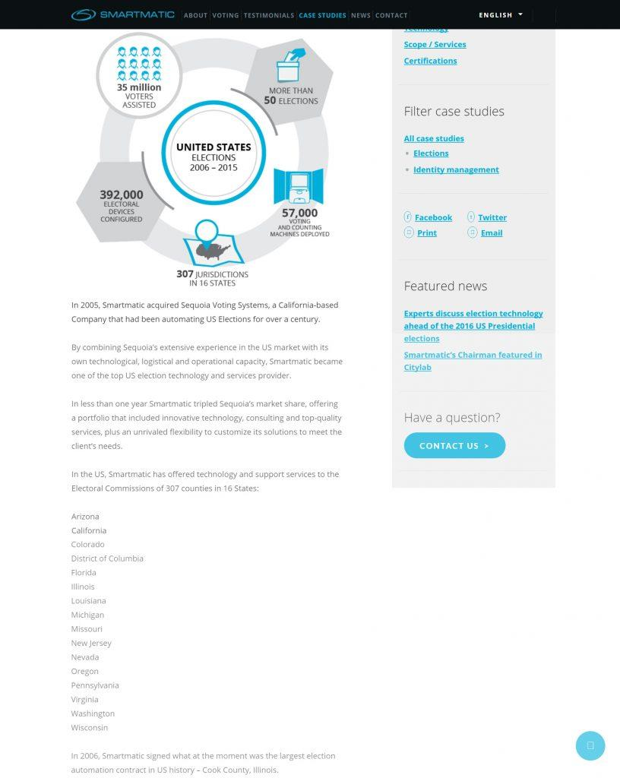
Since 2010 Smartmatic has been found to have been at the heart of election fraud in Mexico, Venezuela, the USA, and the Philippines where the first Presidential election using this system resulted in the victory of Corazon Aquino’s son Benigno Aquino. After mountains of evidence have come to light of Smartmatic’s role in systemic fraud, the IBON Foundation called out Lord Brown as “a foreigner who has made a career out of influencing elections”.
It is an irony of history that not only did Lord Malloch Brown install a second generation cardboard cut tout [sic] into power in the Philippines, but deployed his voting system to undermine the popular Ferdinand Marco Jr in favor of the Liberal Party’s Len Robredo during the 2016 elections. Luckily in the same year that Trump was to beat the system via his landslide popular victory in the USA, a similar victory occurred in opposition to all odds when nationalist President Duterte took office and later demanded the Philippines rid itself of Smartmatic tech.
Lord Malloch Brown’s Ultimate Obsession
Speaking to the World Government Summit of June 2020 alongside Cass Sunstein and an array of other Davos-creatures, Lord Malloch Brown expressed his disdain for the rise of the multipolar alliance led by Russia, China and Trump’s USA which has obviously endangered his life’s work. Malloch Brown hypocritically attacks China for being a regime which has no respect for individual rights and only a concern for “the many”, and then calls out the rise of authoritarian governments “Russia, China, India, Turkey, Hungary and the USA” which he believes must be stopped at all costs saying:
“In the wider world a more authoritarian form of government is the new majority. It is not China alone. This “new majority” embraces leaders who come to power by the ballot box and those who didn’t, but who all share a preference for a nationalist foreign policy, the weakening of domestic institutions and the rule of law”
Malloch Brown obviously felt very comfortable with his audience and assumed no one would think about the obvious hypocrisy of his admitting that these “new majority” nationalists often come to power “by the ballot box” and thus emblemize democratic principles, while his social engineering defense of individual liberties and freedom of choice always occurs outside of the democratic volition of the plebs who are obviously considered too dumb to know what is good for them and also at the expense of the many who must be sacrificed in wars, regime change and anarchy “for the greater good”.
These hypocrisies were made even more obvious in a more recent October 26, 2020 keynote speech on the topic of the UN at 75: Slow Death or New Direction? In this speech, Lord [Malloch] Brown calls for the creation of reformed United Nation to avoid its obsolescence by getting rid of the Security Council which has prevented necessary humanitarian actions due to the insufferable veto held by Russia and China. When asked how the veto may be abolished, Lord Brown admits that nations will never acquiesce and so “the only way you’re going to get these entrenched members to embark on this is to make them largely irrelevant… we have to work around the security council.”
How would anyone be expected to “work around the Security Council” you may ask?
Here Lord Brown answers by calling for the empowerment of “civil society clusters” and “civil society mosaic” that can harness energy coalition of non-state actors. Brown states: “Building variegated coalitions of state and non-state actors willing to be first movers on different parts of this agenda is not a new path to action in the UN. Now it needs to be turbo charged. The world won’t wait for the most plodding and resistant nations to sign up to action”.
Calling the UN Human Rights Council “not fit for purpose” due to its “steady capture” by Russia, China and Cuba who won seats on the body this year, Lord Brown lamented the greatest threat to his vision for a post-national world: “the failures we all individually made pale compared to just the fact that nation states have ultimately- particularly the bigger and more powerful ones- resisted conceding power and sovereignty and decision making to this multilateral body.”
This is the British hand behind the current phase of Russiagate 5.0 which has come closer to its objectives of running an American coup than at any other moment during the past four years. This is the vision of a dystopic post-nation state world order managed by mis-anthropic technocrats who wish to lord over a technetronic feudal dark age in the 21st century and beyond. As much as it might disappoint you to hear this, but at this moment, the most important thing standing in the way of this anti-human world order and your future is the embattled President Trump who requires the serious support of an awakened, informed and active citizenry.
In a future segment we will look more closely at the figure of the late Maurice Strong and the self-induced destruction of western civilization over the past 50 years, and also the battle to resist a bankers’ coup in Britain over 300 years ago which holds peculiar lessons for our current age.

